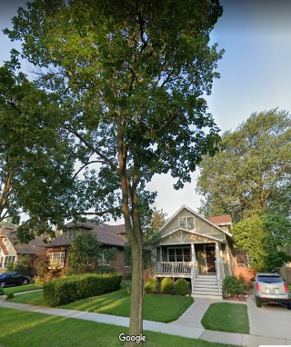 **Ambler EAC Fall Tree Planting**

**is BACK in 2025!** Add value to your homes!

If you would like a Street Tree (within 10 feet of your sidewalk) the **discounted price is $50.**

These are good size - normally retail at about $300.

If you desire a Back Yard Tree, the **discounted price is $75** for your first tree, **$110 if more than one.** We are gladly accepting donations too.

**The BEST time to plant a tree is 20 years ago.**

**NOW is the second-best time!**

The trees are bare root for better survival, native, urban tolerant, provide wonderful shade and cooling in summer, let the winter sun shine through, reduce rainwater runoff, and help Ambler qualify for benefits as a Tree City in PA and USA.

You can select:

A **Small tree** (can grow 12-20 feet tall) like a Red Bud or Serviceberry.

A **Medium tree** (can grow 20-40 feet tall) like a Red Maple or Buckeye.

Or a **Large Tree** (can grow 40-80 feet tall) like an American Linden, Quaking Aspen or a White Oak.

Full Tree Species List on the order form and soon on the Ambler Borough or EAC Website.

Price is determined by **where** it will be planted, not by size. Select your trees from our order form or from the EAC website **by mid-August, 2025**. Pick your tree choice and quantity wanted on the order form. Forward a check payable to Ambler Borough, in memo “EAC Shade Tree”. The EAC will be offering the discount for at least the first 60 trees ordered. Planting will begin mid-November, 2025.

The newly planted trees will need water (by bucket or by rain) once a week until they lose their leaves in winter, once a week through spring, more often during hot dry summer weeks, then once a month for the first 2 years.

Email Mark Setman EAC Tree Planting Chair [MarkSetman@gmail.com](mailto:MarkSetman@gmail.com)

EAC Website for varieties and ordering: www.AmblerEAC.org or the attached order form with the listed varieties.

See you on the shady side of the streets!

* Mark Setman, Ambler Environmental Advisory Council