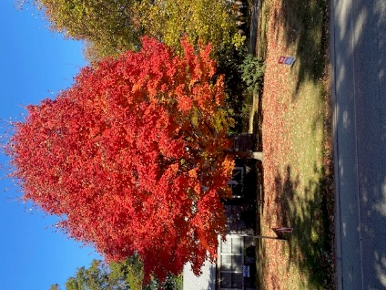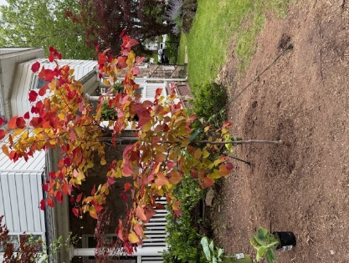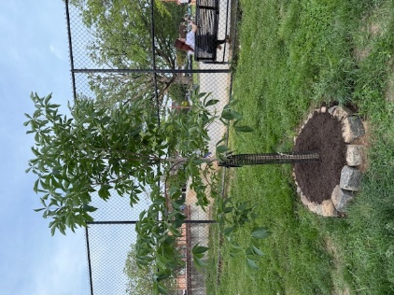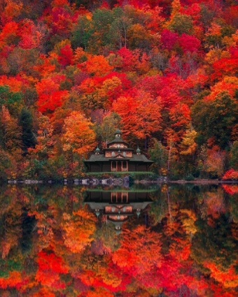

As an **Ambler Borough resident,** you are eligible to request a shade tree for your yard.

Please pick which tree(s) you would like to have planted in your yard. See the notes for the tree characteristics in the Tree Species table. If you want help to choose the tree species, please email [marksetman@gmail.com](mailto:marksetman@gmail.com) or speak with other EAC person:

$50 for your first front yard tree, $75 for a backyard tree, $110 for any additional trees. ($300 value) Can also order “small, medium or large” & pick species later.  
**Choose tree(s), fill in below and deliver to Ambler Borough receptionist:**

Include check payable to” **Borough of Ambler**” (Memo:  **EAC Shade Tree)**

**Check total $________**  
**Property Owner’s name ______________________________________________________**

**Signature of Property Owner _________________________________  Date ___________**

**Tree Planting Address ________________________________________________________**

**Tree Species chosen for Front Yard or along Street at $50__________________________**

**Trees Species chosen for Back Yard at $75_______________________________________**

**Trees Species chosen for additional trees at $110__________________________________**

**Phone __________________________ Email _____________________________________**

**Return form with your check to:  Ambler EAC, 131 Rosemary Ave, Ambler PA by August 25, 2025 or before** to help insure your species pick**, or by the latest order date of September 7, 2025.**

For Questions: Ask Mark Setman, [marksetman@gmail.com](mailto:marksetman@gmail.com) or 215-806-0686 or EAC members

**Donation: If you don’t need a tree, please consider writing a check to donate to a great cause: any amount of money would be greatly appreciated and used to more purchase trees.**